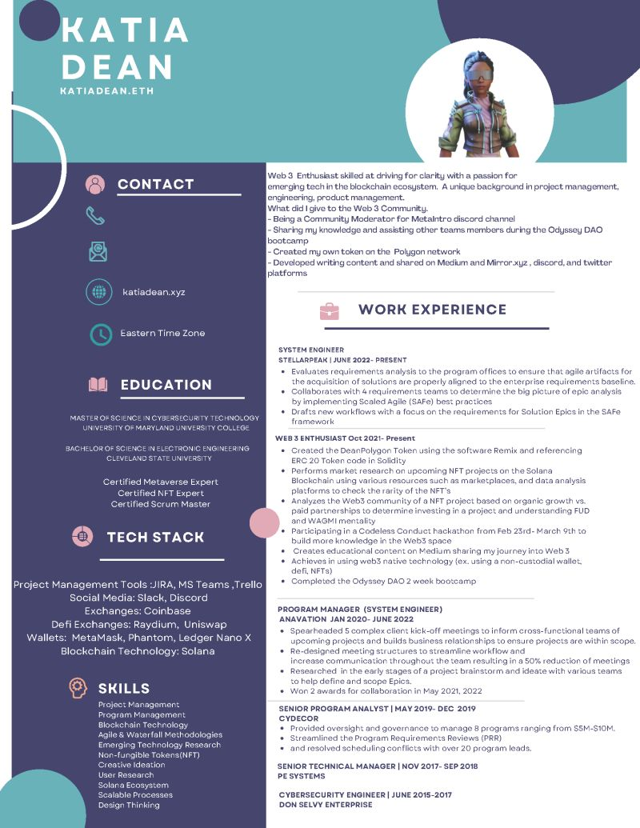
ΚΑΤΙΑ DEAN
KATIADEAN.ETH
CONTACT
Web 3 Enthusiast skilled at driving for clarity with a passion for
emerging tech in the blockchain ecosystem. A unique background in project management, engineering, product management.
What did I give to the Web 3 Community.
-Being a Community Moderator for Metalntro discord channel
-Sharing my knowledge and assisting other teams members during the Odyssey DAO bootcamp
-Created my own token on the Polygon network
-Developed writing content and shared on Medium and Mirror xyz, discord, and twitter platforms
katiadean.xyz
WORK EXPERIENCE
Eastern Time Zone
EDUCATION
MASTER OF SCIENCE IN CYBERSECURITY TECHNOLOGY UNIVERSITY OF MARYLAND UNIVERSITY COLLEGE BACHELOR OF SCIENCE IN ELECTRONIC ENGINEERING CLEVELAND STATE UNIVERSITY
Certified Metaverse Expert Certified NFT Expert Certified Scrum Master
TECH STACK
Project Management Tools :JIRA, MS Teams, Trello Social Media: Slack, Discord Exchanges: Coinbase
Defi Exchanges: Raydium, Uniswap
Wallets: MetaMask, Phantom, Ledger Nano X Blockchain Technology: Solana
SKILLS
Project Management
Program Management Blockchain Technology
Agile & Waterfall Methodologies
Emerging Technology Research
Non-fungible Tokens(NFT) Creative Ideation
User Research
Solana Ecosystem
Scalable Processes
Design Thinking
SYSTEM ENGINEER
STELLARPEAK | JUNE 2022- PRESENT
• Evaluates requirements analysis to the program offices to ensure that agile artifacts for the acquisition of solutions are properly aligned to the enterprise requirements baseline.
• Collaborates with 4 requirements teams to determine the big picture of epic analysis by implementing Scaled Agile (SAFe) best practices
• Drafts new workflows with a focus on the requirements for Solution Epics in the SAFe framework
WEB 3 ENTHUSIAST Oct 2021-Present
• Created the DeanPolygon Token using the software Remix and referencing ERC 20 Token code in Solidity
• Performs market research on upcoming NFT projects on the Solana Blockchain using various resources such as marketplaces, and data analysis platforms to check the rarity of the NFT's
• Analyzes the Web3 community of a NFT project based on organic growth vs. paid partnerships to determine investing in a project and understanding FUD and WAGMI mentality
Participating in a Codeless Conduct hackathon from Feb 23rd-March 9th to build more knowledge in the Web3 space
• Creates educational content on Medium sharing my journey into Web 3
• Achieves in using web3 native technology (ex. using a non-custodial wallet. defi, NFTs)
• Completed the Odyssey DAO 2 week bootcamp
PROGRAM MANAGER (SYSTEM ENGINEER) ANAVATION JAN 2020-JUNE 2022
• Spearheaded 5 complex client kick-off meetings to inform cross-functional teams of upcoming projects and builds business relationships to ensure projects are within scope.
• Re-designed meeting structures to streamline workflow and
increase communication throughout the team resulting in a 50% reduction of meetings:
• Researched in the early stages of a project brainstorm and ideate with various teams to help define and scope Epics.
• Won 2 awards for collaboration in May 2021, 2022
SENIOR PROGRAM ANALYST | MAY 2019- DEC 2019 CYDECOR
• Provided oversight and governance to manage 8 programs ranging from $5M-$10M.
• Streamlined the Program Requirements Reviews (PRR)
⚫ and resolved scheduling conflicts with over 20 program leads.
SENIOR TECHNICAL MANAGER | NOV 2017- SEP 2018
PE SYSTEMS
CYBERSECURITY ENGINEER | JUNE 2015-2017
DON SELVY ENTERPRISE

